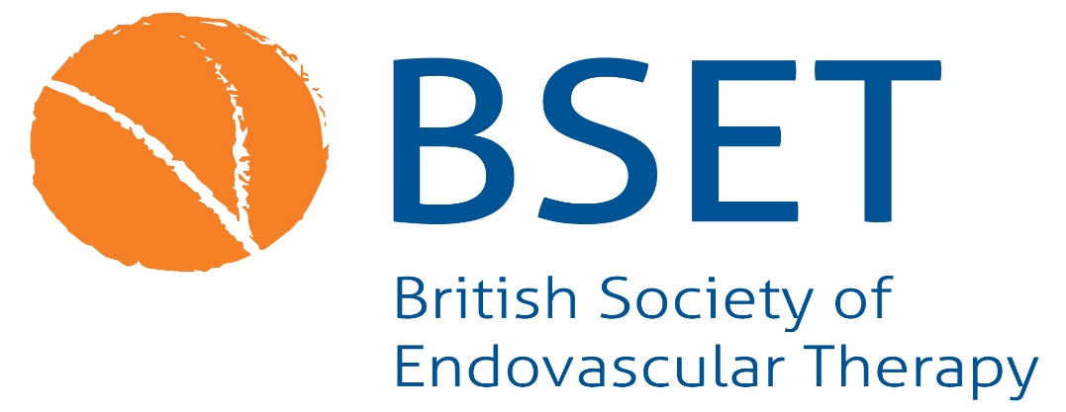

**BSET Travel Fellowship**

The BSET Travel Fellowship, up to the value of £7,500, is available to Specialist Registrars towards the end of higher surgical training or Consultants up to two years post CCT at the closing date for this application. The Fellowship is intended to enable the successful candidate to fund a visit to a unit with recognised expertise of interest to broaden their education and training in endovascular therapy.

Applications should provide a detailed account of the proposed programme of travel, costs involved and objectives to be achieved during the Fellowship, supported by a full Curriculum Vitae giving details of all past and present appointments and publications.

The Fellowship Committee will pay particular attention to originality, scope and feasibility of the proposed itinerary.

Priority will be given to those with a dedicated plan rather than “additional” funding for a pre-arranged secondment.

Candidates must be Members of BSET and engaged in endovascular surgery. The successful candidate will be expected to act as an ambassador for BSET and should be fully acquainted with the aims and objectives of the Association and its role in endovascular therapy.

After the Fellowship, the successful candidate will be required to provide a written report of their Fellowship for inclusion on BSET’s website, and to address the BSET Annual Meeting.  A critical appraisal of the Centre visited, together with an assessment of how the experience will enhance future personal and professional development, should form the basis of the report.

**Closing date for applications: Tuesday 22nd April**

**Interview date: To be conducted via Zoom on Wednesday 7th May from 6pm**

# Criteria

# The BSET Travel Fellowship Programme is specifically designed to assist senior level registrars or early consultants to enhance their endovascular training in centres with recognised expertise of interest to the candidate.

# Projects will be considered that will advance endovascular therapy on the basis of technical exchange.

# Visit length is usually between two weeks and three months.

# The value of each award is normally up to £7,500.

# Funding is given to support specific financial requirements for the trip. This includes travel and accommodation, but does not include meals or general living costs. Priority will be given to those with a dedicated plan rather than “additional” funding for a pre-arranged secondment.

# The BSET Travel Fellowship Programme is intended to support visits to a country other than the one where the applicant is currently based.

# The BSET Travel Fellowship Programme does not support attendance at scientific meetings or conferences.

# No more than one BSET Travel Fellowship may be awarded to each individual member.

# Applications will be evaluated on their merit across a number of areas:

# Suitability of the institution or workshop

# Value for the applicant’s training, research and publications

# Benefit to the applicant’s home institution

# Financial feasibility of the project

# Overall contribution to endovascular therapy.

# Terms and conditions

# Successful applicants must submit a report of 500 – 750 words to BSET following the visit and be available to present at the following BSET Annual Meeting.

# Reports must be submitted within two months of the end date of the visit.

# BSET may use material from Travel Fellowship reports on the BSET website, social media and other promotional materials. If you have any concerns about the use of your material please tell us.

# Awarded funds must be returned in full if for any reason a successful applicant is unable to complete the planned trip.

# BSET is unable to ‘top up’ applications in the instance that actual cost of travel exceeds the funding received.

# Under no circumstances is a BSET Travel Fellowship transferable to another person.

# BSET Travel Fellowship funds can only be used to support the trip specified in the ‘visit details’ section of the application form. Successful applicants must seek agreement from BSET if any details change after the application has been submitted.

# BSET may request a partial return of funds in the event that a successful applicant undertakes a shorter trip than the one detailed in the application.