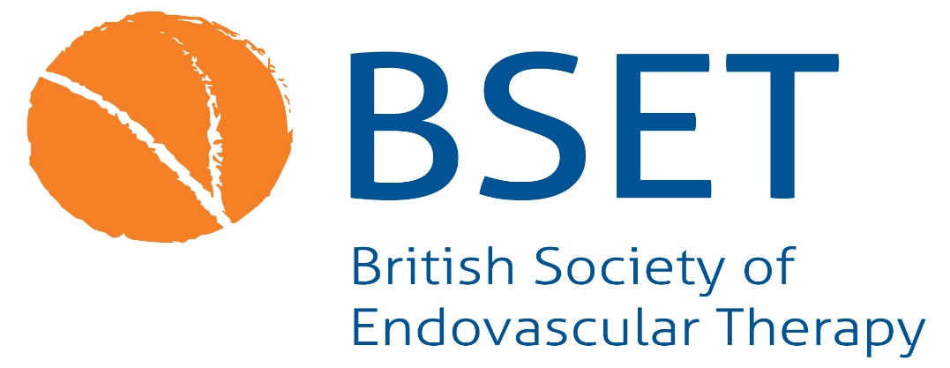

**BSET Fellowship Programme**

**Applications are invited for the 2025 BSET Fellowship Programme.**

**One** six month post is now available for a vascular or interventional radiology trainee providing an opportunity to acquire new or more complex endovascular skills, to be spent in a vascular unit within the UK.

Training in a full range of endovascular techniques will be encouraged including percutaneous transluminal angioplasty, endovenous procedures, lower limb and deep venous endovascular therapies, and the treatment of abdominal and thoracic aortic aneurysms.

The Fellowships will be awarded and administered through the British Society of Endovascular Therapy.

Applications for the Fellowships will be encouraged from trainees in all related disciplines, with an interest in the endovascular treatment of vascular disease.  **Applications are welcome from post-CCTs.**

Applicants will need to be members of the British Society of Endovascular Therapy.

**Closing date for applications: Tuesday 22nd April**

**Interview date: To be conducted via Zoom on Wednesday 7th May from 6pm**

**Scope of Fellowships**

BSET will award up to £40,000 for one endovascular training placement of six months’ duration.

Support for the Fellowship will take the form of a salary for a 6 month period.  The salary will be based on a ST7/8 working in either Vascular Surgery or Interventional Radiology. The Fellowships seek to provide support for dedicated training in endovascular therapy.

The successful applicant will be given a choice of units in which to undertake their Fellowship.  It is expected that all successful centres will be able to offer dedicated training in endovascular therapy, including percutaneous transluminal angioplasty, endovenous procedures, lower limb and deep venous endovascular therapies, and the treatment of abdominal and thoracic aortic aneurysms.

The Fellowship Programme is dedicated to advancing knowledge and training in endovascular procedures to provide local opportunities for vascular surgical trainees to gain the necessary experience and training for Consultant Vascular Surgeon or Interventional Radiology appointments. The Fellowship requires completion of mandatory and desirable courses, e.g. radiation protection and ultrasound, if not already undertaken

Accreditation for the training programme will be the responsibility of the candidate, the centre involved, and the local Surgical Training Committee.

**Application Process**

The Fellowship will be awarded by open competition, which will involve an application followed by competitive interview.  It is expected that applicants will be senior trainees in their relevant disciplines, or have completed their training programme.

It is anticipated that most applicants will be derived from the fields of Vascular Surgery or Interventional Radiology, and successful candidates will usually be experienced in the treatment of peripheral vascular and aneurysmal disease.   Suitable candidates from other disciplines will be eligible to apply.

The British Society of Endovascular Therapy wishes to appoint candidates who have a longstanding interest in the endovascular treatment of vascular disease, and aim to specialise in this therapy in their Consultant appointment.

**Application Procedure**

Candidates can apply for a Training Fellowship by sending a **500 word** personal statement describing how the Fellowship would supplement their current clinical experience, and also attaching a **two page CV.**

Applications should be e-mailed to office@bset.co.uk

**Closing date for applications: Tuesday 22nd April**

**Interview date: Wednesday 7th May from 6pm via Zoom**

Short-listed applicants will be interviewed by a panel appointed by the British Society of Endovascular Therapy.

### 